             **Name**   : SAFRIZAL RAHMAN

           ` **Nim**      : 2341760151

**Kelas**    : 1-G

**Number :** 22

**Materi**  : SELECTION part 1

**BASIC PROGRAMMING PRACTICUM REPORT**

**Github Name:** [**https://github.com/safrizalrahman46**](https://github.com/safrizalrahman46)

2.1 experiment 1

make a file.java then type the following code

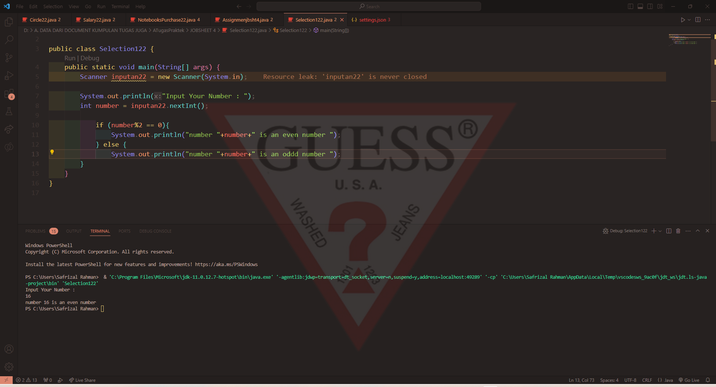

The result is gonnna be like this



**Question! 1.**   
1. Modify the above selection statement (if-else) by using Ternary Operator! We know that Ternary Operator could be used as a selection statement as well.

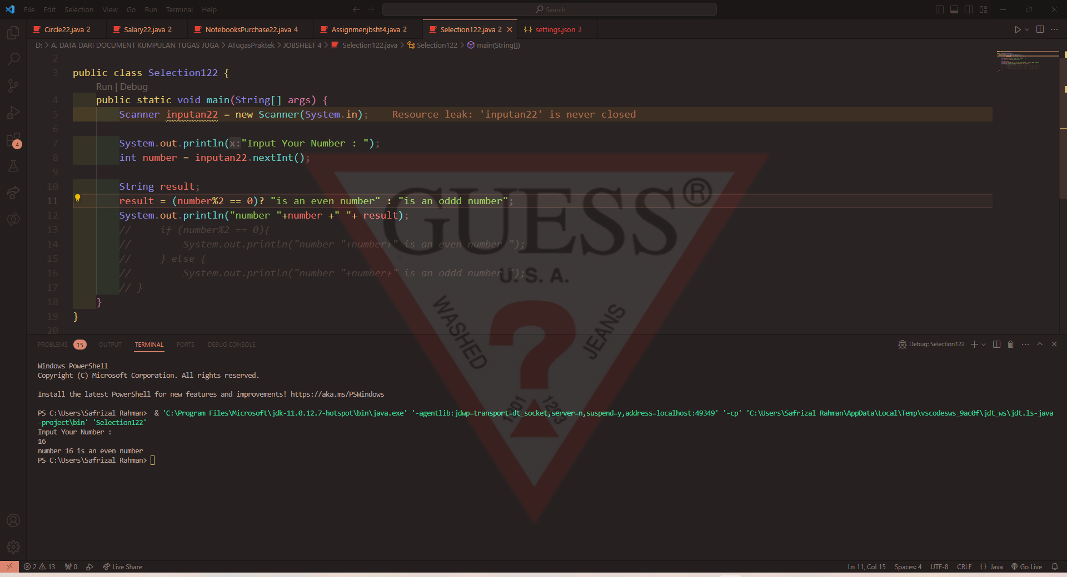  
2. Compile, run and observe the result!

  
3. Commit and push the changes into your repository!   
4. Finally, please explain why the output of the program before and after the changes has a similar output.